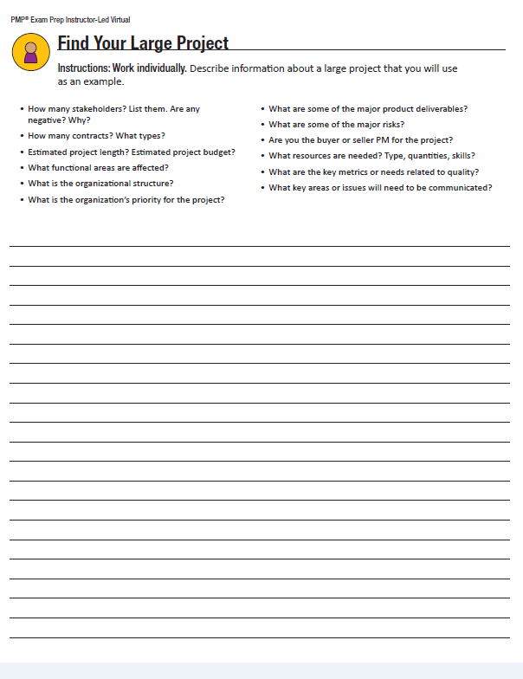



**Project Title: The County Community Library Project**

**Project Sponsor:** Gerald Maccombe, County Commissioner

**Project Description:** The county is interested in building a new library for the community. The building will be built in the same location of the old library that was demolished two years ago. It will be small with a minimal lending library (mainly for children) and a large lounge for reading and access to the internet, designed after a state of the art Community Internet Library Café in Sweden. In addition to the general public areas, the building will have washrooms, a kitchen and rest area for staff, a librarian area with resources to assist and a meeting room for training and activities. The purpose of the library is to service the northern part of the county that has not had access to library resources since the closing of the previous library.

**Project Manager and Authority Level:** Jackie Campbell will be the project manager and will have the authority to select team members and determine the schedule within the limit of one year. Budgeting will be managed by the Office of the County Commissioner and the County Financial Department. **Business Case:** Since the community was promised a replacement library after the demolition of the original County Community Library, there have been many complaints from residents about the lack of these services. The ‘Library Action Committee’ has threatened to sue the county for not providing what is considered basic services as listed in the county charter of services. If the outcome of this law suit is against the county, it could cost the county more than re-building a new library. The County Board and the Commissioner has determined that it is in the best interest of everyone to initiate a project for a new community library. As a side benefit, the budget and taxes for the library will be taken from the collected taxes for resident services and the county will no longer be responsible for paying taxes on the unused land. There is also a side benefit to provide a community meeting place to encourage safe socialization.

**Resources Preassigned:** The previous head librarian of the Community Library will be dedicated to the project (for her unique experience in populating and managing the lending library), one county IT manager will be dedicated to coordinate the technology and devices for resourcing the internet capabilities) and the head county contractor will manage the contracting of the construction crew and oversee the work to specifications.

**Key Stakeholders:** Available as needed **Project Sponsor:** Gerald Maccombe, County Commissioner **Project Manager:** Jackie Campbell

**Project** **Team:** Sherri Lipscome: Head Librarian/consultant Burke Davis: Head County Contractor

Stephen Scherling:IT/Device Manager Elsa Andersson: IT Manager (Sweden)

Building a new library for your community:  you work for the county and you have just been assigned to be the project manager.  Think of all of the stakeholders, all the workers who will be building the facility, who will be the sponsor, etc. We want you to visualize a large project and how you would use the PMI process to manage it. If you can do this you will have a better understanding of how to use the tools as well.  We will need to see your documentation describing the project, the stakeholders, all the workers, who will be the sponsor, etc.



**2**

**Stakeholder Requirements:** Operational library/internet facility for public use

Additional paperwork to be developed: architectural drawings of facility, library management software specifications and specifications of internet library café design from Sweden

**Key Project Deliverables:**

* Schedule and WBS
* Stakeholder Repository and Register
* Analysis of library behaviour and customer service expectations
* Analysis of risks to operation
* Focus Groups and Surveys

**Key Product Deliverables:**

* New building with ample parking and easy access
* Lending library stocked with children’s books with wide array of topics for all youth
* Select magazines and senior citizen reading material
* Large reading lounge circled by privacy booths with advanced connectivity for internet engagement
* Central librarian area, kitchen and break room and auxiliary meeting room

**Assumptions:**

* Land is licensed for public use and ready for building
* Library management software is sufficient for lending library
* Pre-fab privacy carols can be reasonably shipped from Sweden
* Cost of computers will not exceed existing budget
* Swedish consultant will have enough time to commit to the project
* Construction on the external facility will begin right away and be completed within 8 months to allow for completion of inside

**Constraints:**

* Stakeholder Register due in one week – focus groups to begin in three weeks, town hall meetings in a month
* Initial procurement list due to Finance Department in two weeks
* Scope is to remain a limited service facility
* WBS due in two weeks – activity lists due in three weeks
* Risk register due in two weeks

**Measurable Project Objectives:**

* Facility is completed by January 31, 2020
* Community usage of facility exceeds usage of previous facility by 30%
* Customer satisfaction above 75%

**Project Approval Requirements**

* The sponsor will approve the budget, the construction company contract and architectural plan, the major risks, the WBS and the project plan before work begins.



3

**High Level Risks**

* External factors could cause delays and cost overruns on construction that could exceed budget
* There could be unseen delays on the receipt of product/materials from Sweden
* Building and parking permits have been affected by labor disputes and may be delayed
* Library software will be a complicated configuration on the new computers causing difficult configuration and potential delay

**Project Completion Criteria**

The final building cost and schedule will be represented in a report outlining the functionality of the library, how many residents it will service, the budget and tax savings and number of people it will employ. The report will be signed off by the project team and sanctioned by the Office of the Commissioner, the finance department, City Council and the Mayor.

**Project Authorization, Sponsor**

________________________________Gerald Maccombe, County Commissioner

**Project Authorization, Co-Sponsors**

**_____________________________ ______________________________**Stephen Baker, Mayor Alfred Whitehouse, Head of City Council